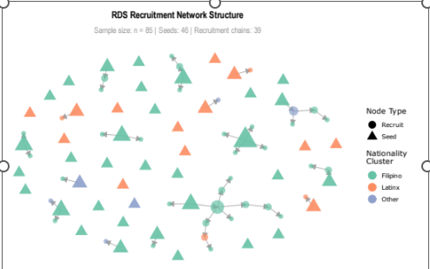
Figure 1 RDS Recruitment Network Structure Recruitment chains showing seed nodes (triangles) and recruit nodes (circles). Node colours represent nationality clusters, which node size proportional to out-degree (number of recruits). Lines show recruiter-recruit relationships. Source: Authors’ Own Work

